Apache Solr - Faceting

Faceting in Apache Solr refers to the classification of the search results into various categories. In this chapter, we will discuss the types of faceting available in Apache Solr −

* **Query faceting** − It returns the number of documents in the current search results that also match the given query.
* **Date faceting** − It returns the number of documents that fall within certain date ranges.

Faceting commands are added to any normal Solr query request, and the faceting counts come back in the same query response.

Faceting Query Example

Using the field **faceting**, we can retrieve the counts for all terms, or just the top terms in any given field.

**Note:** csv files is already saved in “exercise_files” directory. Use vscode to view files.

As an example, let us consider the following **books.csv** file that contains data about various books.

id,cat,name,price,inStock,author,series_t,sequence_i,genre_s

0553573403,book,A Game of Thrones,5.99,true,George R.R. Martin,"A Song of Ice

and Fire",1,fantasy

0553579908,book,A Clash of Kings,10.99,true,George R.R. Martin,"A Song of Ice

and Fire",2,fantasy

055357342X,book,A Storm of Swords,7.99,true,George R.R. Martin,"A Song of Ice

and Fire",3,fantasy

0553293354,book,Foundation,7.99,true,Isaac Asimov,Foundation Novels,1,scifi

0812521390,book,The Black Company,4.99,false,Glen Cook,The Chronicles of The

Black Company,1,fantasy

0812550706,book,Ender's Game,6.99,true,Orson Scott Card,Ender,1,scifi

0441385532,book,Jhereg,7.95,false,Steven Brust,Vlad Taltos,1,fantasy

0380014300,book,Nine Princes In Amber,6.99,true,Roger Zelazny,the Chronicles of

Amber,1,fantasy

0805080481,book,The Book of Three,5.99,true,Lloyd Alexander,The Chronicles of

Prydain,1,fantasy

080508049X,book,The Black Cauldron,5.99,true,Lloyd Alexander,The Chronicles of

Prydain,2,fantasy

Let us post this file into Apache Solr using the **post** tool.

[Hadoop@localhost bin]$ post -c Solr_sample books.csv

On executing the above command, all the documents mentioned in the given **.csv** file will be uploaded into Apache Solr.

Now let us execute a faceted query on the field **author** with 0 rows on the collection/core **my_core**.

Open the web UI of Apache Solr and on the left-hand side of the page, check the checkbox **facet**, as shown in the following screenshot.

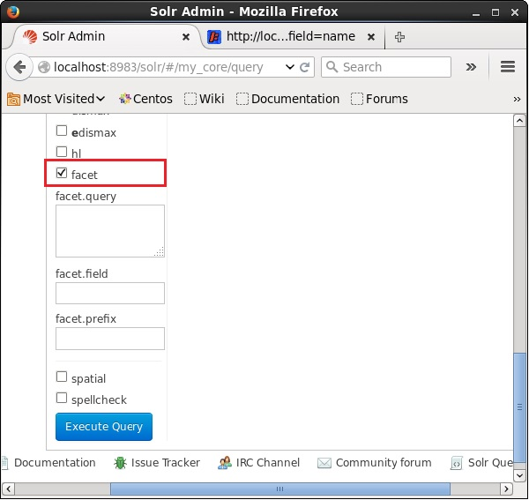

On checking the checkbox, you will have three more text fields in order to pass the parameters of the facet search. Now, as parameters of the query, pass the following values.

q = *:*, rows = 0, facet.field = author

Finally, execute the query by clicking the **Execute Query** button.

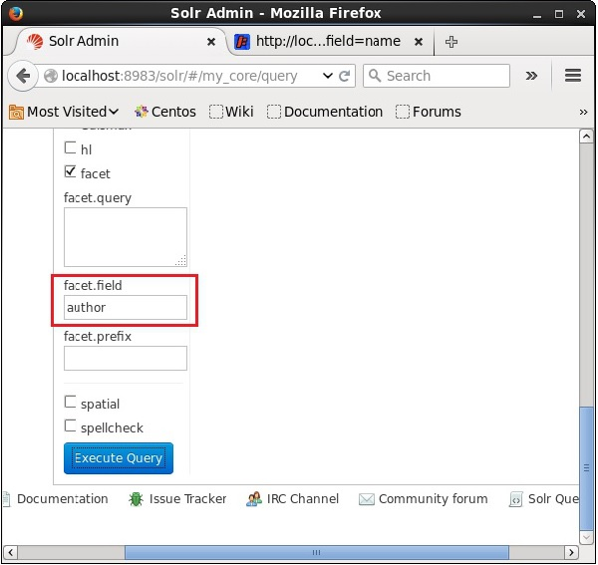

On executing, it will produce the following result.

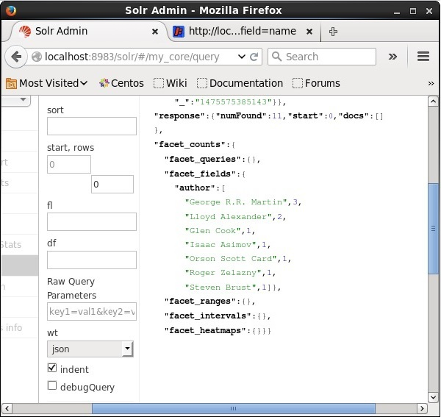

It categorizes the documents in the index based on author and specifies the number of books contributed by each author.